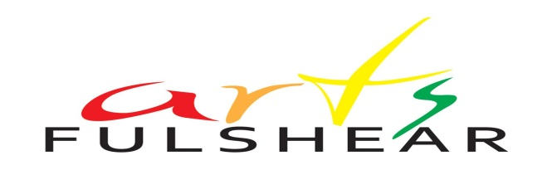
PLEIN AIR ARTISTS INVITATIONAL
Fulshear Towne Scene: “Deep in the Art of Fulshear”
CONTEST FOR ARTS FULSHEAR ART, WINE, and CHOCOLATE
Fulshear Art Walk Spring 2014

We are already planning for our 2014 Artwalk, and this time with more of everything! The Arts Fulshear Artwalk Committee is currently organizing an Artwalk that will include wine and chocolate sampling, more entertainment & fun, more artistic categories, and more marketing to the surrounding areas. So mark your calendars for April 26th, 2014.
In anticipation of the Fulshear Artwalk event in April, we are currently holding a contest for our member and nonmember invitees to submit a painting or drawing of a “Fulshear Towne Scene.” Art accepted into the final round will be exhibited at the Arts & Drafts event: Ray’s Grill, February 4th , 2014, from 6 – 8 pm. One winner will be selected from art accepted into the final round. Artists are encouraged to attend and art must be picked up by 8:00 pm that evening.
The winner of this contest will have his or her piece showcased in our marketing - print, web, and social media - beginning in January, 2014. Artist contact information and biography will also be showcased and winning artist will be required to sign a release for Arts Fulshear to use this piece for promotional purposes. Winning Artist will also be guaranteed a booth space free of charge to display art and plein air “paint the town” of Fulshear during the event in April.
To qualify to be considered: 1. Artist must be invited by Arts Fulshear and RSVP acceptance of invitation, 2. Art (in any medium) must be created en plein air between receipt of invitation and January 15th, 2014, at 3 pm, 3. Art can be any size limited to 24” on any side, including frame, 4. Art must be submitted in quality digital photo form (300 dpi, and up to 2MB file size), along with attached registration form by 6 pm on January 15, 2014, via email to eugenia@mindful-art.com, and, 5. Winning artist must also be able to paint or draw a town scene on-site at our event on April 26, 2014.
A confirmation will be sent to artist when art is received via email. Additional details will be sent to finalists. For more information please contact Eugenia Garcia at 713-303-4381 or email: eugenia@mindful-art.com.
We look forward to hearing from you!
2014 Arts Fulshear Artwalk Committee

